Code assignment -1
Name : kunal yaduvendu
Uni roll no: 12515000862
Class roll no: 32
Section: FB

Leetcode: 1464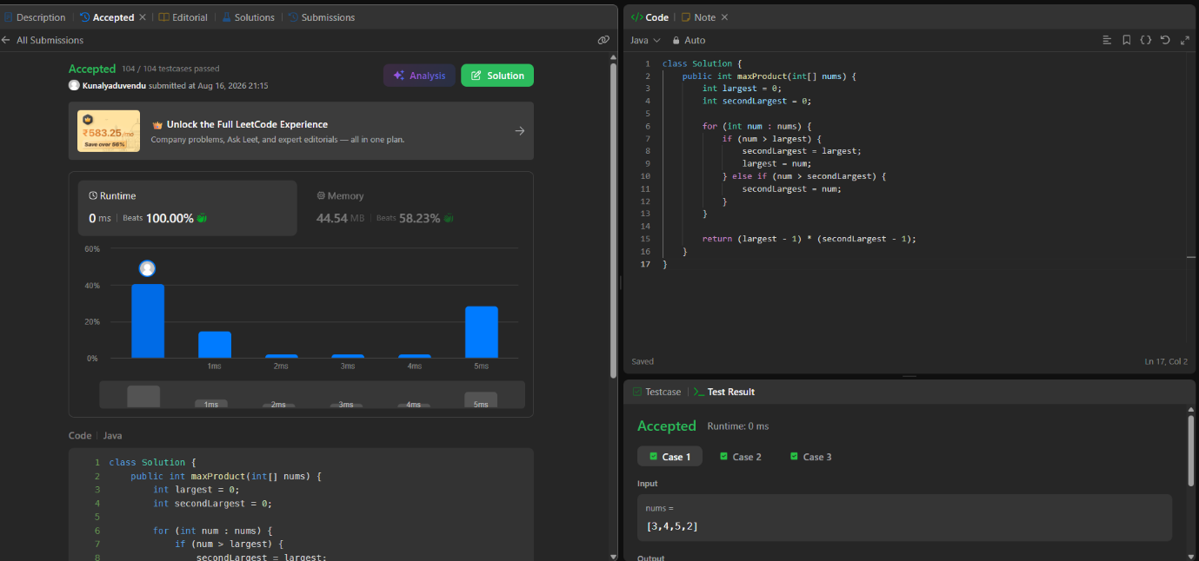

Leetcode:162
Problem : find peak element
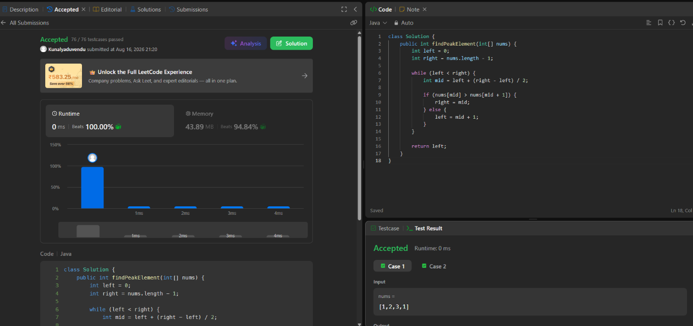

Leetcode:33
Problem: search in sorted array
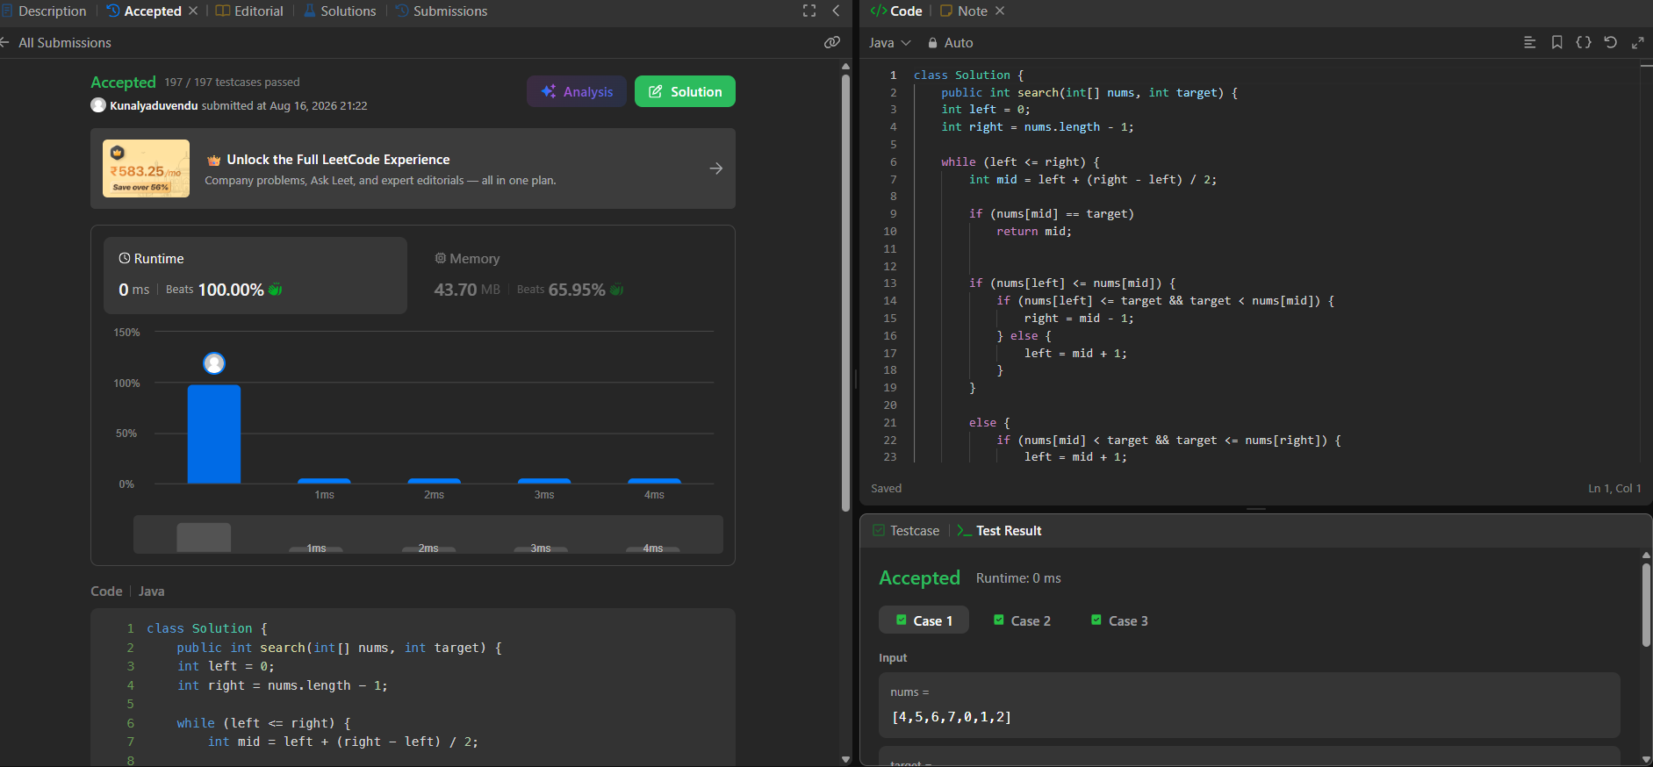
Leetcode:3477
Problem: Fruits Into Baskets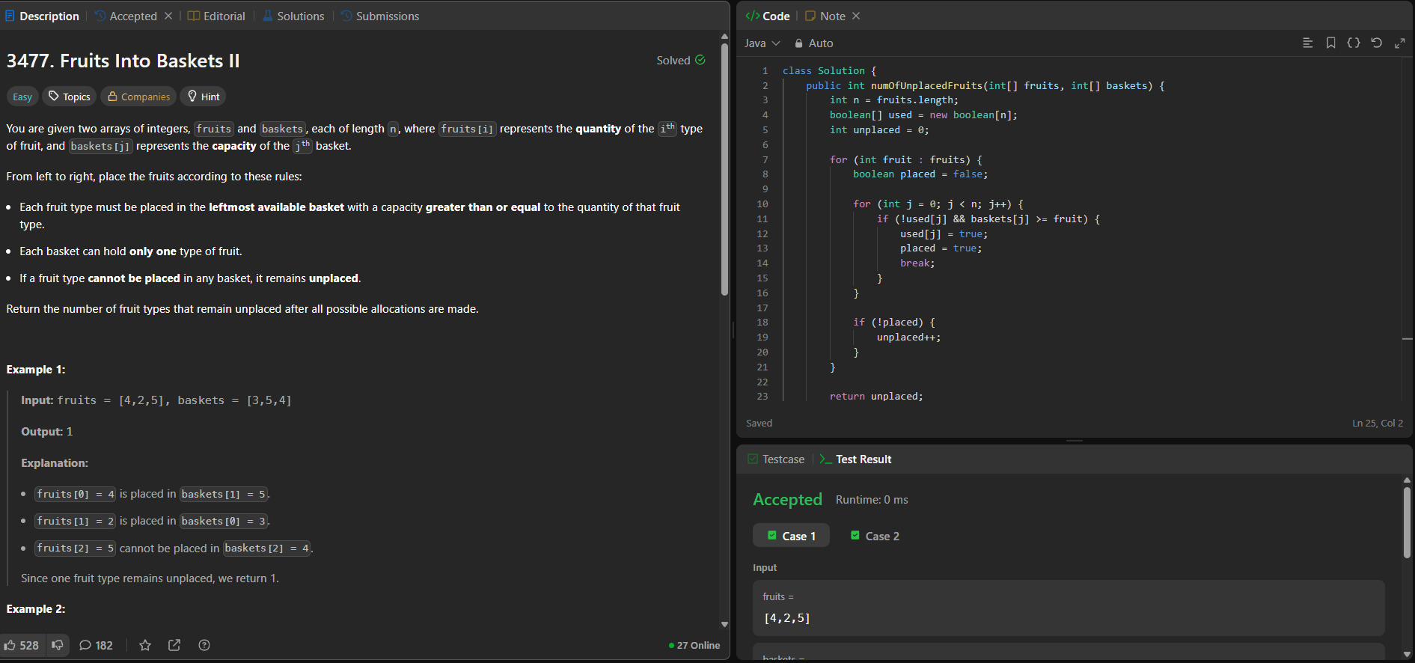

Leetcode:121
Problem: best time to but and sell stock
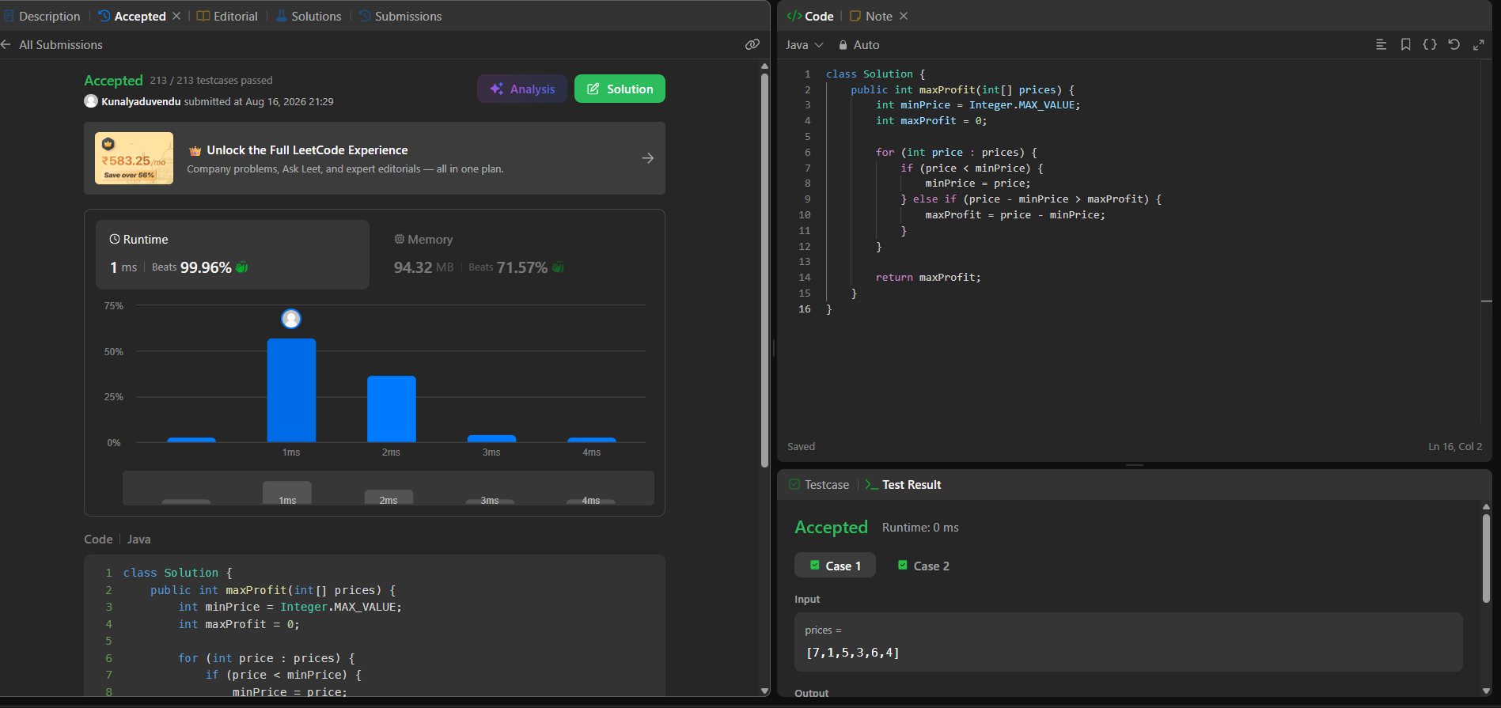
Leetcode: 1
Problem : two sum
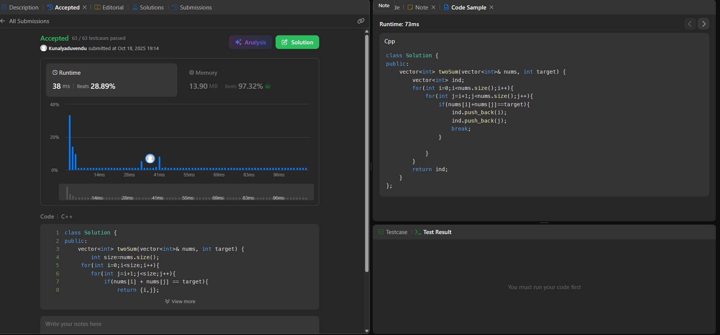
Leetcode:1365
Problem: how many numbers are smaller than current number
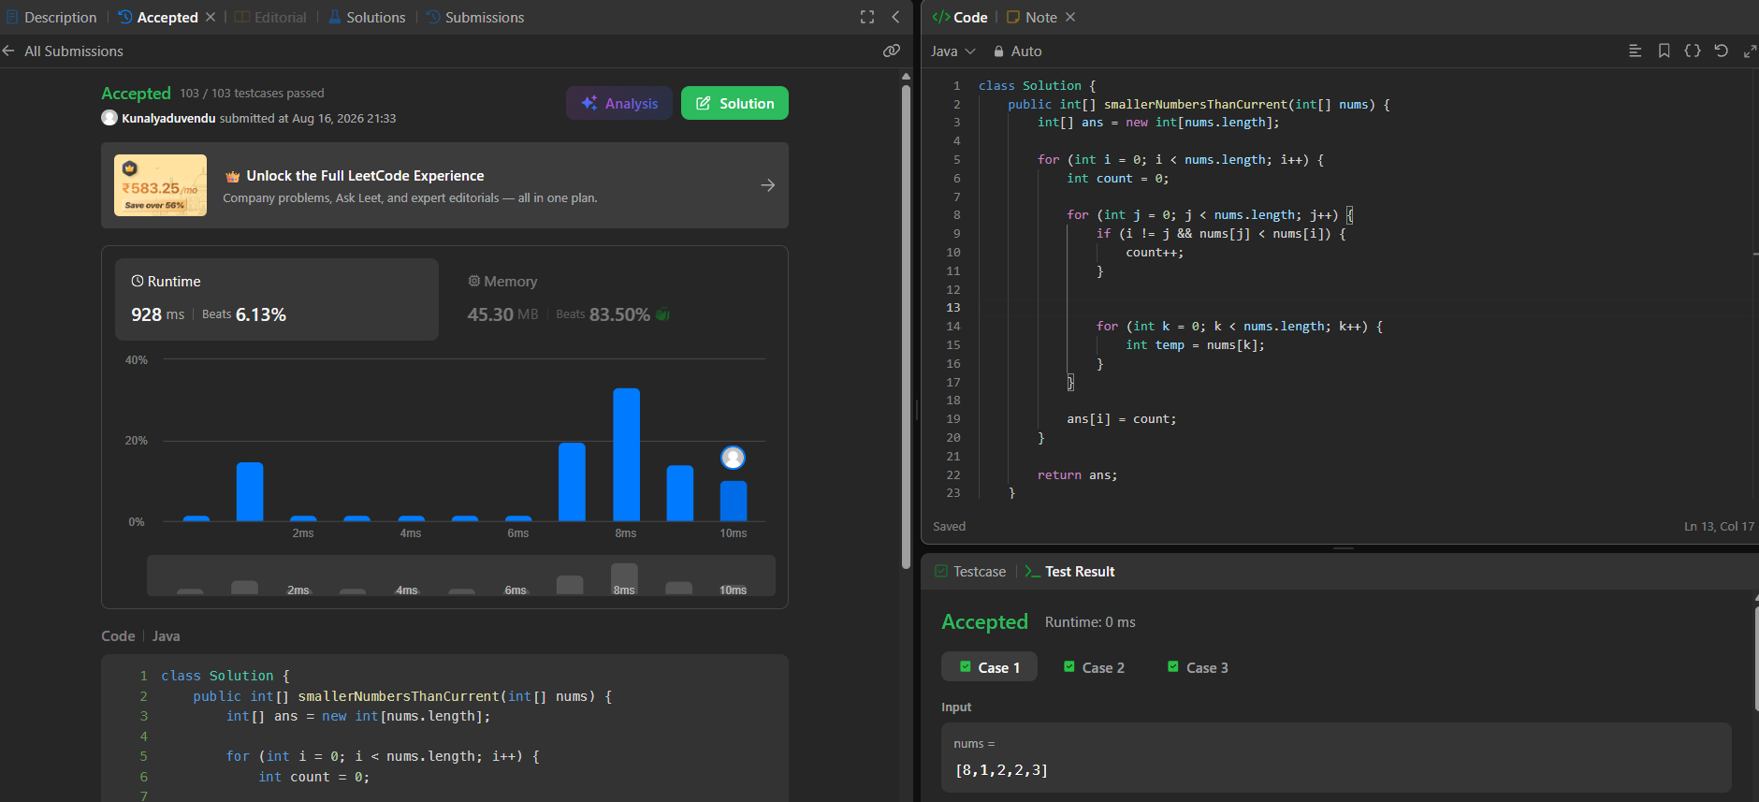
Leetcode:628
Problem: maximum product of three numbers
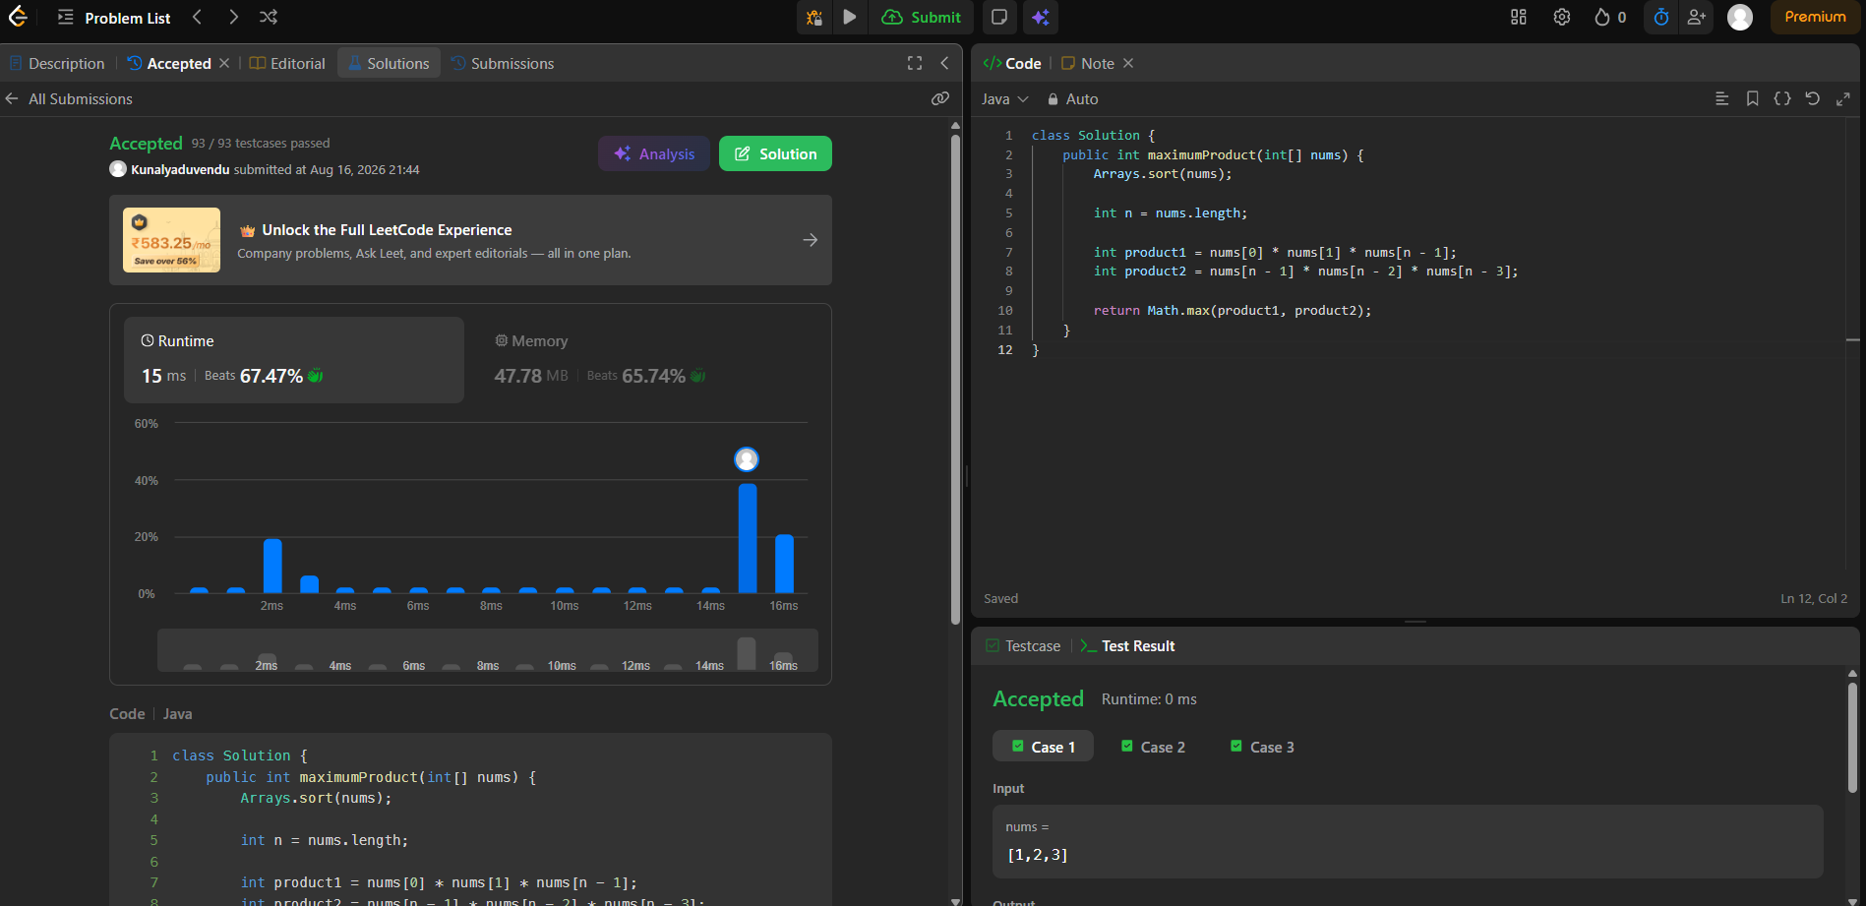

Leetcode:26
Problem: remove duplicates from sorted array
